This half term we are learning about different festivals and celebrations in this country and around the world.

We will create neon night creatures, sparkly firework pictures, role play around the bonfire and make real Christmas cards for printing.

We have been learning
about the Hindu festival
of light Diwali and
making Rangoli patterns. We drew Mehndi hand designs and danced to Indian music.
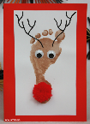
The children have already

made Christmas cards
that are off to the printers and we will set up a Christmas shop and role play in December; writing cards and posting them.
A full copy of the planning is on the notice board for your perusal.
Remembrance Day
Mon 11th November
There is a collection pot and various poppy items on our welcome table. Please donate and help yourself to some poppy badges, pencils and stickers.

There will be an opportunity to look through your child’s special books and share summaries of development in December. But please always feel free to chat to your child’s key person about your child’s development or any concerns at any time.

Keep telling us about your child’s WOW MOMENTS outside Pre-school so we can share these with their friends. There are Wow slips in the Parents’ folder on the Welcome table.
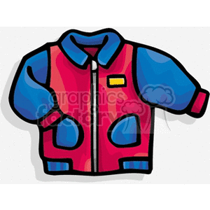
Brrrrrrr
The chillier weather is here so please don’t forget to always
bring a coat & hat to each
session.

Thank you for all
the recent support
with fundraising. The Rotary Raffle raised £108 and the draw takes place on 19th November. GOOD LUCK!

Our policies have recently
been reviewed and
emailed to all parents. It is required by Ofsted that all parents/carers read and

accept our policies while we have their child in our care.
Parents are requested to sign the sheet on the welcome table to confirm they accept our policies.
The children will be
having a YOGA session
on Mon 4th November.
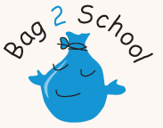
Our next Bag2School
collection is on Friday
6th December so have a good clear out before Christmas. A reminder what can and can’t be collected;

Men’s, ladies’ and children’s
clothing, paired shoes (tied
together), handbags, hats,
bags, scarves, ties, jewellery,
lingerie, belts, soft toys,
linen, curtains, towels,
bedding.

Duvets, blankets, pillows,
carpets, rugs, school
uniform, corporate clothing,
textile off cuts, soiled or
ripped clothing.

Applications for Primary school places in Devon opens 15 November 2019.
if your child was born between the 1 September 2015 and 31 August 2016, you will be able to apply for your child's school place from 15 November 2019.
You can apply online at www.devon.gov.uk/admissionsonline

Our Christmas Show
will be on Wednesday 11th December at 2.00pm. All parents and relatives are welcome to come and enjoy our seasonal entertainment and refreshments.

Plymtree Pre-school Christmas Fayre is on Sunday 8th December in the village hall.
Get in touch if you would like a table to sell your Christmas crafts and food.
Come and do some gift shopping and enjoy the festive spirit.

Key Person/ Child
Clare Elaine
Hazel Dominic
Isaac Szymon
Harry George LP

Angela Elaina
Evelyn Noah
George Scarlett
Daisy Chloe

DIARY DATES

Mon 4 Nov Yoga
Wed 6 Nov MusicSeeds
Fri 8 Nov Ball Skills
Mon 11 Nov MusicSeeds
Mon 18 Nov RugbyTots
Mon 25 Nov MusicSeeds
Mon 2 Dec MusicSeeds
Wed 4 Dec Visit to Plymtree
Primary School
Fri 6 Dec Bag2School
Sun 8 Dec Christmas Fayre
Mon 9 Dec MusicSeeds
Wed 11 Dec Christmas Show
2.00pm
Wed 18 Dec Christmas Party
Wed 18 Dec LAST DAY

Term dates 2019/20
Autumn
Wed 4th Sep – Wed 18th Dec
Half term 21st Oct – 25th Oct
Spring
Mon 6th Jan – Fri 27th Mar
Half term 17th Feb – 21st Feb
Summer
Wed 15th Apr – Mon 20th Jul
Half term 25th May – 29th May

Term dates 2020/21
Autumn
Mon 7th Sep – Wed 16th Dec
Half term 26th Oct – 30th Oct
Spring
Mon 4th Jan – Wed 31st Mar
Half term 15th Feb – 19th Feb
Summer
Mon 19th Apr – Wed 21st Jul
Half term 31st May – 4th Jun

Best wishes,
Clare, Elaine, Angela,
Elaina & Ruth.

