This half term we are enjoying lots of books.
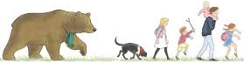
Going on a Bear Hunt
Sensory bare foot walk through the elements & sequencing the story using pictures.

The Gruffalo
Making, baking and
eating Gruffalo crumble - No Gruffalo's will be harmed in this activity!

Elmer
Junk modelling a
colourful herd of elephants. Role playing with Elmer masks & colour sorting.

Rainbow Fish
Colour mixing & making
shiny fish. Catching alphabet fish in our pond with fishing lines.

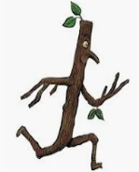
Stickman
Counting activities &
matching quantity to
numerals.
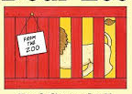

Dear Zoo
Size sorting - which animals will fit into which box?


Tiger That Came To Tea
Tea party time, what would you bring to our tea party?



Wed 4th Feb Sleepover day. Come dressed in your comfiest P.J’s and bring your favourite book from home to read to your friends.




Dance with Jo continues
this term; going on more
magical adventures.

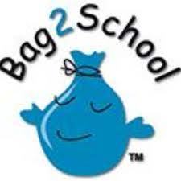

Our last Bag2School collection made £78, thank you for all the donations. The next collection is on 11th May.

More info on the scheme can be found on:
http://uk.bag2school.com/

Men’s, ladies’ and children’s
clean & not ripped
clothing, paired shoes,
handbags, hats,
bags, scarves, ties, jewellery,
bras, belts & socks.



Please Label all lunch boxes, water bottles, coats, pre-school jumpers and wellies.
We have a No Nut Policy so please no nuts including peanut butter.
Always adhere to the 48 hr rule after sickness & diarrhoea. Do not send your child back in to pre-school

until a full 48 hours after the last bout.
Thank you for your support.



Primary School Admissions
For those children starting primary school in September 2026, admissions close 15th January. You must apply by this date. More information:
https://www.devon.gov.uk/educationandfamilies/school-information/apply-for-a-school-place/apply-for-a-primary-school-place/



We love to hear about the children’s successes outside Pre-school so please share them with us by filling in a WOW slip. You can pick a slip up from the parents’ folder on the welcome table.



Pre-school polo tops and sweatshirts can be purchased from us. They are not compulsory, but it can make it easier to get the children dressed in the morning!
Polo tops are £10 and sweatshirts £12, available in sizes 3-4yrs & 5-6 yrs



DIARY DATES

Mon 19 Jan Dance
w/c 26 Jan Parent Chats
w/c 2 Feb Parent Chats
Wed 4 Feb Pyjama Day
Mon 9 Feb Dance
Mon 2 Mar Dance
Mon 30 Mar Dance
Mon 11 May Bag2School

YEAR 2025/26 TERM DATES
Autumn Term 2025
Wed 3rd Sep – Fri 19th Dec Half term 27th Oct – 31st Oct

Spring Term 2026
Mon 5th Jan – Wed 1st Apr
Half term 16th Feb – 20th Feb

Summer Term 2026
Mon 20th Apr – Fri 17th Jul Half term 25th May –29th May

Bank Holiday Mon 4th May 2026 (Pre-school is closed)

YEAR 2026/27 TERM DATES
Autumn Term 2026
Mon 7th Sep – Wed 16th Dec Half term 26th Oct – 30th Oct

Spring Term 2027
Mon 4th Jan – Wed 24th Mar
Half term 15th Feb – 19th Feb

Summer Term 2027
Mon 12th Apr – Wed 21st Jul Half term 31st May – 4th Jun

Bank Holiday Mon 3rd May 2027 (Pre-school is closed)

Best wishes,
Clare, Elaine, Elaina, Angela & Ruth.

